REPUBLIC OF CAMEROON
*********
Peace-Work-Fatherland
***************
MINISTRY OF HIGHER EDUCATION
REPUBLIQUE DU CAMEROUN
********
Paix-Travail-Patrie
********
MINISTERE DE L’ENSEIGNEMENTS
SUPERIRIEUR




DESIGN AND IMPLEMENTATION OF A SMART ACADEMIC RESOURCE MANAGEMENT PLATFORM (ACADEX)
By
TEBEI NOEL FORKANG
24SWE5589
Software Engineering

A Dissertation presented to the department of Computer Engineering, school of Engineering of PHIBMAT affiliated to the University of Bamenda in partial fulfillment of the requirement for the award of Bachelor’s of technology (BTech) in Software Engineering.

SUPERVISOR:
Eng. ASONGAFACK PATRICK LYONGA JULY,2026

ECLARATION
I, TEBEI NOEL FORKANG, hereby declare that this project entitled "DESIGN AND IMPLEMENTATION OF A SMART ACADEMIC RESOURCE MANAGEMENT PLATFORM (ACADEX)" is my original work, carried out under the supervision of my assigned project supervisor (ASONGAFACK PATRICK) in partial fulfillment of the requirements for the award of the Bachelor of Technology (BTech) degree in Software Engineering at PHIBMAT. This work has not been submitted, either wholly or in part, to any other institution for the award of any degree, diploma, or certificate. I further affirm that all information, ideas, and materials obtained from other authors have been appropriately acknowledged and referenced in accordance with accepted academic standards.
I therefore take full responsibility for the authenticity of this work.
Student's Name
TEBEI NOEL FORKANG
Signature: ___________________
Date: _______________________

CERTIFICATION
This is to certify that the project entitled "DESIGN AND IMPLEMENTATION OF A SMART ACADEMIC RESOURCE MANAGEMENT PLATFORM (ACADEX)" was carried out by TEBEI NOEL FORKANG under the supervision of the academic supervisor in partial fulfillment of the requirements for the award of the Bachelor of Technology (BTech) degree in Software Engineering at the PHIBMAT. his work is original and has been completed in accordance with the academic regulations and standards governing the award of the degree.
Academic supervisor: Mr. ASONGAFACK PATRICK LYONGA
Sign:_____________________________ Date:_______________________

DEDICATION
To all Students and Lecturers using Acadex

ACKNOWLEDGEMENT
My profound gratitude goes to my academic supervisor, Mr. ASONGAFACK PATRICK LYONGA, for his invaluable guidance, constructive criticism, encouragement, and continuous support throughout this research. His expertise and commitment greatly contributed to the success of this work.
I also express my sincere appreciation to the Dean, the Director, and all the Lecturers of the Department of Software Engineering, PHIBMAT for equipping me with the knowledge and skills that made this project possible.
Special thanks go to my classmates for their valuable feedback, testing of the ACADEX platform, and helpful suggestions during its development and evaluation.
I am deeply grateful to my family for their unwavering love, prayers, patience, and constant encouragement throughout my academic journey.
Finally, I extend my appreciation to my colleagues, especially Njah Hiddy, for actively testing the platform and providing academic materials that were uploaded to ACADEX, thereby contributing significantly to the practical evaluation and improvement of the system.

ABSTRACT
Access to internship topics, defended project reports, past examination papers, and academic mentorship remains a significant challenge for many students, affecting research quality and academic performance. This study presents the design and implementation of ACADEX, a Smart Academic Resource Management Platform developed to centralize academic resources and promote learning, research, collaboration, and mentorship. The system was developed using the Agile Software Development methodology with React.js for the frontend, Node.js and Express.js for the backend, MongoDB as the database, JWT for secure authentication, and RESTful APIs for communication between system components. The implemented platform provides centralized access to internship topics, verified project reports, past examination papers, AI-powered academic assistance, lecturer mentorship, discussion forums, institutional announcements, and secure subscription services. The results demonstrate improved accessibility to academic resources, enhanced collaboration, and effective preservation of valuable research outputs. It is concluded that ACADEX provides an efficient, secure, and scalable solution for academic resource management and offers a strong foundation for future AI-driven educational innovations.
Keywords: Smart Academic Resource Management, Educational Technology, React.js, Node.js, Express.js, MongoDB, Artificial Intelligence, Academic Collaboration.

TABLE OF CONTENTS
Table of Contents
DECLARATION ii
CERTIFICATION iii
DEDICATION iv
ACKNOWLEDGEMENT v
ABSTRACT vi
TABLE OF CONTENTS vii
LIST OF FIGURES ix
CHAPTER ONE 1
GENERAL INTRODUCTION 1
1.1 Background of the Study 1
1.2 STATEMENT OF THE PROBLEM 2
1.3 RESEARCH QUESTIONS 3
1.4 HYPOTHESIS 3
1.6 SIGNIFICANCE OF THE STUDY 4
1.7 DEFINITION OF TERMS 4
1.8 ORGANIZATION OF STUDY 5
CHAPTER TWO 7
2. LITERATURE REVIEW 7
2.2 EVOLUTION OF ACADEMIC RESOURCE MANAGEMENT SYSTEMS 2.2.1 Traditional Academic Resource Management 7
2.3 REVIEW OF EXISTING SYSTEMS 9
2.4 REVIEW OF EXISTING SYSTEMS 13
2.6 RESEARCH GAP 16
2.7 CHAPTER SUMMARY 17
CHAPTER THREE 19
3. RESEARCH METHODOLOGY 19
3.1 AREA OF STUDY 19
3.2.PLANNING 19
3.2.3 Hardware and Software Requirements 25
3.3 IMPLEMENTATION 27
3.4 ANALYSIS 30
3.6 CHAPTER SUMMARY 33
CHAPTER FOUR 35
4. PRESENTATION AND DISCUSSION OF FINDINGS 35
4.1 PRESENTATION OF FINDINGS 35
4.2 DISCUSSION OF FINDINGS 36
CHAPTER FIVE 37
5. SUMMARY OF FINDINGS, CONCLUSION AND RECOMMENDATIONS 37
5.1 SUMMARY OF FINDINGS 37
5.2 RECOMMENDATIONS 38
5.3 CONCLUSION 38
5.4 LIMITATIONS OF THE STUDY 39
5.5 SUGGESTIONS FOR FURTHER RESEARCH 39
REFERENCES IEEE-style 41
APPENDIX A: SYSTEM SCREENSHOTS 43
APPENDIX B: QUESTIONNAIRE 45
APPENDIX C: SAMPLE SYSTEM OUTPUTS 46

LIST OF FIGURES
Figure 1.1: Functional Diagram of the Proposed System 22
Figure 2 System Usecase Diagram 23
Figure 3 Flowchat Diagram 24
Figure 4 Class diagram 24
Figure 5 Questionnaire Response Rate Chart 35
Figure 6 Summary of Key Findings from the Survey 36
Figure 7 Question papers, Internship Topics, Report Repository Screenshot 43
Figure 8 Candidate Dashboard Screenshot 43
Figure 9 Chat section candidate site 44
Figure 10 Subscription component 44
Figure 11 Questionaire 45
Figure 12 Push Notification 46
Figure 13 Email notification 46

LIST OF TABLES
Table 1 LIST OF ABBREVIATIONS xi
Table 2 Comparative Analysis of Existing Systems 16
Table 3 Hardware Requirements 25
Table 4 Software Requirements 26

LIST OF ABBREVIATIONS
Table 1 LIST OF ABBREVIATIONS
Abbreviation | Meaning
ACADEX | Academic Digital Ecosystem
AI | Artificial Intelligence
API | Application Programming Interface
B.Tech | Bachelor of Technology
CSS | Cascading Style Sheets
CRUD | Create, Read, Update, Delete
DB | Database
IDE | Integrated Development Environment
HTML | HyperText Markup Language
HTTP | HyperText Transfer Protocol
HTTPS | HyperText Transfer Protocol Secure
ICT | Information and Communication Technology
IoT | Internet of Things
JWT | JSON Web Token
LMS | Learning Management System
MoMo | Mobile Money
MongoDB | Mongo Database
MTN | Mobile Telephone Network
NoSQL | Not Only SQL
ODM | Object Data Modeling
OOP | Object-Oriented Programming
PHIBMAT | Professional Higher Institute of Business, Management and Technology
RBAC | Role-Based Access Control
REST | Representational State Transfer
RESTful | Representational State Transfer based services
SDLC | Software Development Life Cycle
SMS | Short Message Service
SQL | Structured Query Language
UI | User Interface
URL | Uniform Resource Locator
UX | User Experience
UAT | User Acceptance Testing
VS Code | Visual Studio Code
XML | Extensible Markup Language

CHAPTER ONE

GENERAL INTRODUCTION

1.1 Background of the Study
The rapid growth of Information and Communication Technology (ICT) has significantly transformed the education sector by improving teaching, learning, communication, and access to academic resources. Digital technologies such as online learning platforms, digital repositories, cloud computing, and artificial intelligence are increasingly being integrated into educational environments to enhance accessibility, flexibility, and efficiency in knowledge delivery [1].
Despite these technological advancements, many higher education institutions, especially in developing countries, continue to experience challenges in the management and accessibility of academic resources. Students often encounter difficulties obtaining internship topics, defended project reports, past examination questions, academic presentations, mentorship opportunities, and reliable academic information. These resources are frequently distributed across different departments, lecturers, personal archives, and informal communication channels, making access difficult and unreliable.
Consequently, many students depend on informal sources such as senior students, lecturers, social media groups, or unofficial platforms to obtain academic materials. This approach is often time-consuming, creates unequal access to educational resources, and affects effective academic preparation. The process of selecting suitable internship and research topics remains a major challenge, while valuable student projects are often lost after graduation due to the absence of centralized digital repositories for preserving academic work.
Access to past examination materials also remains a concern in many institutions. These resources are valuable for revision and academic preparation, yet they are often not systematically archived or made easily accessible to students. Similarly, students requiring additional academic guidance frequently face difficulties identifying qualified mentors and establishing structured mentorship relationships.
Communication between institutions and students presents another challenge. Important academic information such as examination schedules, internship announcements, deadlines, and institutional updates often passes through multiple intermediaries before reaching students, which may result in delays, incomplete information, or reduced effectiveness.
Furthermore, the emergence of Artificial Intelligence (AI) has introduced new opportunities in education through intelligent tutoring, automated research assistance, personalized learning, and academic support systems [2]. However, many educational platforms still operate as isolated systems, focusing mainly on individual functions such as learning materials or communication rather than providing an integrated environment that combines academic resources, mentorship, collaboration, and intelligent assistance.
These challenges highlight the need for a centralized digital platform capable of managing academic resources, preserving student knowledge, improving collaboration, and providing accessible academic support services.
To address these issues, this project presents the design and implementation of ACADEX (Academic Ecosystem), a web-based smart academic resource management platform developed using React.js, Node.js, Express.js, and MongoDB. The platform provides centralized access to internship topics, past examination papers, defended projects, presentations, AI-powered academic assistance, lecturer mentorship, institutional announcements, and collaborative learning resources for students across HND, BTS, Bachelor's, Licence, and Master's levels. Additionally, ACADEX integrates MTN Mobile Money and Orange Money services to support subscriptions and lecturer booking payments, creating a comprehensive digital environment that enhances academic resource accessibility, knowledge preservation, and collaboration among students, lecturers, and institutions.

1.2 STATEMENT OF THE PROBLEM
The development of ACADEX was motivated by several academic challenges encountered by students during their educational journey, particularly during the author's Higher National Diploma (HND) program.
One major challenge is the difficulty students face when selecting suitable internship and research topics. In the absence of a dedicated platform providing categorized and innovative project ideas based on departments, specializations, and emerging technologies, students often depend on lecturers, classmates, or unreliable internet sources, which may not always provide relevant solutions.
After selecting a topic, accessing previous defended project reports remains another significant challenge. Many academic reports are stored as printed documents, personal files, or individual archives, making them difficult to access. This often leads to research duplication, increased preparation time, and difficulties in understanding proper project structures and methodologies. Furthermore, valuable student research is frequently lost after graduation because there is no centralized system for preserving and sharing academic works.
Students also experience challenges accessing past examination papers for effective revision. These materials are often distributed informally or available only through costly printed resources, limiting equal access to learning materials [3]. Similarly, obtaining academic mentorship remains difficult due to the lack of structured systems that allow students to identify qualified lecturers, request guidance, and schedule consultations.
Another problem is inefficient communication between institutions and students. Important academic information related to examinations, internships, registrations, and other activities may experience delays when transmitted through multiple communication channels.
Existing educational platforms often provide only specific services such as online learning, file storage, or communication, without combining essential academic resources into a single integrated ecosystem.
These challenges affect students' academic productivity, limit collaboration, reduce access to reliable educational resources, and contribute to the loss of valuable academic knowledge. Therefore, there is a need for a centralized academic platform that facilitates resource sharing, mentorship, communication, and preservation of student research. The proposed smart academic resource management platform addresses these challenges by providing an integrated digital ecosystem that connects students, lecturers, and institutions through accessible academic services.
1.3 RESEARCH QUESTIONS
* How can a smart academic resource management platform improve access to academic resources such as past examination papers, research reports, and internship/project topics for students?
* How can a centralized digital platform facilitate effective communication and collaboration between students, lecturers, and academic institutions?
* How can the integration of features such as academic resource sharing, mentorship management, and research preservation improve students’ academic productivity and learning experience?
How can institutions communicate efficiently with students?
* How can academic collaboration be enhanced among students and lecturers?
* How can digital payment systems improve access to premium educational services?
1.4 HYPOTHESIS
H₁ Hypothesis:
The implementation of a smart academic resource management platform significantly improves students’ access to academic resources, communication with academic stakeholders, mentorship opportunities, and preservation of academic works.
1.5 OBJECTIVES OF STUDY
1.5.1 Main Objective
To design and develop a smart academic resource management platform that centralizes academic resources, facilitates communication and mentorship, and improves students’ access to reliable educational materials and academic support services
1.5.2 Specific Objectives
- Design a secure web-based academic ecosystem for students, lecturers, and administrators.
- Develop an intelligent repository for internship topics across multiple academic programs.
- Create a centralized repository for verified project reports and PowerPoint presentations.
- Implement AI-powered research and study assistance.
- Implement lecturer discovery, booking, and online mentorship services.
- Integrate secure payment systems using MTN Mobile Money and Orange Money.
- Preserve students' academic work by enabling permanent publication of defended reports.
- Provide administrative tools for user verification, announcements, pricing management, complaints handling, and advertisement management.
- Develop a scalable system capable of supporting future mobile applications and national educational services.

1.6 SIGNIFICANCE OF THE STUDY
The successful implementation of the proposed smart academic resource management platform provides significant benefits to several stakeholders.
Students
Students gain centralized access to internship topics, academic reports, examination papers, AI assistance, mentorship services, communication tools, and collaborative learning environments, improving their academic preparation and productivity.
Lecturers
Lecturers can publish academic materials, receive mentorship bookings, generate additional income through academic guidance services, and interact more efficiently with students.
FutureStudents
The platform ensures that valuable academic knowledge generated by previous students remains permanently accessible, creating a continuous learning resource for future generations.
1.7 DEFINITION OF TERMS
ACADEX (Academic Digital Ecosystem)
A digital academic ecosystem mobile application designed to connect students, lecturers, and academic institutions by providing centralized access to academic resources, project topics, research reports, examination materials, mentorship services, and academic communication tools.
Academic Resources
Educational materials and information used to support learning and research activities, including project reports, examination papers, internship topics, and other academic documents.
Academic Repository
A centralized digital storage system used for preserving, organizing, and providing access to academic works and research documents.
Mentorship
A structured guidance process where experienced individuals, such as lecturers or professionals, provide academic support, advice, and knowledge to students.

1.8 ORGANIZATION OF STUDY
This report is organized into five chapters, with each chapter focusing on a specific aspect of the development of the proposed smart academic resource management platform (ACADEX).
Chapter One presents the general introduction of the study. It discusses the background of the study, problem statement, research questions, hypothesis, objectives, significance of the study, definition of terms, and organization of the study. This chapter provides the foundation for understanding the challenges that motivated the development of the Academic Ecosystem Mobile App. Chapter Two focuses on the literature review. It examines existing academic resource management systems, digital learning platforms, educational repositories, mentorship platforms, and related technologies. It also presents a review of existing solutions, their limitations, and the gaps that the proposed platform seeks to address. Chapter Three describes the research methodology and system design. It presents the methods used for data collection and analysis, requirements analysis, feasibility study, system architecture, database design, and the technologies, tools, and frameworks selected for the development of the platform. Chapter Four presents the system implementation and evaluation. It describes the development process, implementation of the major system modules, user interfaces, database integration, testing procedures, and the results obtained from the completed system. Chapter Five provides the conclusion and recommendations of the study. It summarizes the major findings, evaluates how the developed platform addresses the identified challenges, and proposes possible improvements and future enhancements to increase the effectiveness and scalability of the system.

CHAPTER TWO

LITERATURE REVIEW
2.1. Introduction
A literature review is an essential part of academic research that examines existing knowledge, theories, and previous studies related to a particular research problem. It enables researchers to understand the current state of knowledge, identify gaps in existing studies, and establish the need for further research. In software engineering projects, the literature review provides a theoretical foundation for system development by analyzing existing technologies, methodologies, and software solutions relevant to the proposed study [4].
The rapid advancement of Information and Communication Technology (ICT) has significantly transformed the management of academic resources. Educational institutions have increasingly adopted digital technologies to improve teaching, learning, communication, and the preservation of academic information. Despite these advancements, many institutions continue to face challenges such as fragmented academic resources, inadequate preservation of research outputs, limited collaboration among stakeholders, and the absence of integrated platforms that support multiple academic services [5].
This chapter reviews the evolution of academic resource management systems, relevant concepts, and previous studies related to digital learning, academic repositories, artificial intelligence in education, and integrated academic platforms. It also examines existing academic systems, identifies their strengths and limitations, and establishes the research gap that justifies the development of the proposed Smart Academic Resource Management Platform (ACADEX).

2.2 EVOLUTION OF ACADEMIC RESOURCE MANAGEMENT SYSTEMS
2.2.1 Traditional Academic Resource Management
Before the widespread adoption of digital technologies, academic resources were managed primarily through physical libraries, departmental archives, printed reports, and paper-based examination materials. Students relied heavily on institutional libraries, lecturers, and previous graduates to obtain research reports, lecture notes, and past examination papers. While these methods supported academic activities, they presented several challenges, including limited accessibility, duplication of research, deterioration of printed materials, and the permanent loss of valuable academic works after students graduated [6].
As student populations increased and educational institutions expanded, traditional resource management became increasingly inefficient. The need for faster information retrieval, long-term preservation of academic materials, and improved accessibility encouraged institutions to adopt digital technologies for academic resource management.

2.2.2 Digital Learning Platforms
The introduction of Academic Information Systems (AIS) marked a significant milestone in the digital transformation of higher education. These systems were primarily developed to automate administrative processes such as student registration, course allocation, examination management, transcript generation, and result processing. They improved operational efficiency, reduced paperwork, and enhanced institutional record management [7].
Although Academic Information Systems significantly improved administrative operations, their primary focus remained institutional management rather than comprehensive academic resource sharing. Most systems provided little or no support for preserving student research projects, accessing internship topics, facilitating mentorship, or promoting collaboration among students and lecturers
2.2.3 Learning Management Systems
The evolution of internet technologies led to the emergence of Learning Management Systems (LMS), which expanded digital education beyond administrative functions. Platforms such as Moodle, Google Classroom, Blackboard, and Canvas enabled institutions to deliver course materials, administer assessments, facilitate online discussions, and support virtual learning environments [8].
Learning Management Systems greatly improved access to educational content and promoted flexible learning. However, their core functionality remains centered on course delivery and classroom management. They generally provide limited support for preserving defended student projects, managing internship resources, facilitating structured academic mentorship, or maintaining long-term academic repositories that extend beyond individual courses.
2.2.4 Digital Academic Repositories
The increasing volume of academic research led many institutions to establish digital repositories for preserving scholarly publications, theses, dissertations, and institutional research outputs. Repository platforms such as DSpace and EPrints have enabled universities to archive research materials, improve information retrieval, and increase the visibility of academic publications [9].
Despite these developments, many repositories focus primarily on postgraduate theses and published research while providing limited support for undergraduate projects, internship reports, presentation materials, and other practical academic resources. Consequently, valuable student research often remains inaccessible or is permanently lost after graduation, reducing opportunities for knowledge sharing and future academic development.
2.2.5 Artificial Intelligence in Education
Recent advances in Artificial Intelligence (AI) have introduced intelligent educational systems capable of providing personalized learning experiences, automated tutoring, intelligent recommendations, content generation, and academic support. AI technologies are increasingly being integrated into educational platforms to assist learners with problem-solving, adaptive learning, and research activities [10].
Although AI has significantly enhanced digital education, many existing applications function as standalone assistants that are not fully integrated with institutional academic resources. As a result, students often use separate platforms for learning, research, mentorship, and communication, reducing the efficiency of their academic experience.
2.2.6 Integrated Academic Ecosystems
Recent developments in educational technology emphasize the integration of multiple academic services into unified digital ecosystems. Rather than providing isolated functions such as course management, document storage, or communication, modern academic platforms increasingly seek to combine learning resources, collaboration tools, digital repositories, mentorship services, artificial intelligence, and institutional communication within a single environment [11].
This integrated approach improves accessibility, enhances collaboration, promotes knowledge preservation, and provides a more comprehensive academic experience for students, lecturers, researchers, and educational institutions. The proposed Smart Academic Resource Management Platform follows this direction by integrating essential academic services into a centralized digital ecosystem that supports resource sharing, research preservation, mentorship, academic communication, and intelligent learning support.

2.3 REVIEW OF EXISTING SYSTEMS
This section reviews previous studies related to academic resource management, digital learning systems, institutional repositories, artificial intelligence in education, and integrated academic platforms. The review highlights the objectives, findings, strengths, and limitations of existing studies to establish the research gap addressed by the proposed Smart Academic Resource Management Platform.
2.3.1 Study on Digital Learning Platforms
According to Bond, M. et al. (2020), digital learning platforms have become essential tools for supporting teaching and learning in higher education. Their systematic review found that learning management systems improve students' access to learning materials, facilitate online assessments, and enhance communication between instructors and learners. The study concluded that digital learning technologies contribute significantly to flexible learning environments, particularly in institutions adopting blended and online education [12].
Despite these advantages, the study observed that most learning management systems primarily focus on course delivery and assessment. They provide limited support for preserving student research projects, managing internship resources, facilitating academic mentorship, or integrating multiple educational services into a unified platform. These limitations indicate the need for more comprehensive academic systems.

2.3.2 Study on Institutional Digital Repositories
Lynch (2003) emphasized that institutional repositories play an important role in preserving scholarly publications and improving access to academic knowledge. The study argued that digital repositories enable universities to archive research outputs, increase research visibility, and ensure long-term preservation of intellectual resources [13].
However, many institutional repositories concentrate mainly on postgraduate theses, journal publications, and faculty research. Undergraduate project reports, internship documents, presentation materials, and practical academic resources are often excluded, limiting the preservation of valuable student-generated knowledge.
2.3.3 Study on Artificial Intelligence in Education
Holmes, Bialik, and Fadel (2019) examined the application of Artificial Intelligence in education and concluded that AI technologies have the potential to transform learning through intelligent tutoring, personalized instruction, automated assessment, and adaptive learning support. The study further explained that AI can improve students' learning experiences by providing instant feedback and individualized academic assistance [14].
Although AI enhances learning effectiveness, the study noted that many AI applications operate independently of institutional academic systems. Consequently, students often rely on separate platforms for learning, research, communication, and resource management, reducing the efficiency of digital education
2.3.4 Study on Knowledge Management in Higher Education
According to Kidwell, J. J., Vander Linde, K. M., and Johnson, S. L. (2000), effective knowledge management enables higher education institutions to organize, preserve, and disseminate academic knowledge for future use. The study highlighted that educational institutions generate substantial intellectual assets, but inadequate knowledge management practices often result in the loss of valuable information and research outputs [15].
The authors recommended implementing digital knowledge management systems capable of preserving institutional knowledge and improving access to academic information. However, the study focused mainly on organizational knowledge management rather than integrated student-centered academic ecosystems.
2.3.5 Study on Smart Education Systems
Zhu, Yu, and Riezebos (2016) introduced the concept of Smart Education, describing it as an educational model that integrates information technology, intelligent services, digital resources, and collaborative learning to improve teaching and learning outcomes. The researchers argued that modern educational systems should provide intelligent, personalized, and interactive learning environments capable of supporting learners throughout their academic journey [16].
Although Smart Education provides an excellent framework for future educational technologies, the study did not propose a complete platform integrating internship management, academic repositories, mentorship, AI-assisted research, communication, and academic publication within a single ecosystem.
2.3.6 Summary of Related Studies
The reviewed studies demonstrate that considerable progress has been made in digital learning, academic repositories, knowledge management, and artificial intelligence in education. Learning management systems improve instructional delivery, institutional repositories preserve scholarly publications, and AI technologies provide intelligent learning support.
However, none of the reviewed studies presents a comprehensive solution that integrates academic resource management, internship topic selection, project publication, research preservation, AI-assisted learning, mentorship, academic communication, and collaboration into a single platform. This observation establishes the need for the proposed Smart Academic Resource Management Platform, which combines these essential academic services within one integrated digital ecosystem.

2.4 REVIEW OF EXISTING SYSTEMS
Following the review of related studies, it is important to examine existing academic platforms that have been developed to address various educational needs. These systems have contributed significantly to digital education by improving access to learning resources, communication, and academic services. However, most of them focus on specific aspects of education rather than providing a comprehensive academic ecosystem. This section reviews selected local and international platforms to identify their strengths, limitations, and areas requiring improvement.
2.4.1 Cameroon HND Platform (CMR HND Platform)
The Cameroon HND Platform is one of the most widely used online academic platforms for Higher National Diploma (HND) students in Cameroon. It primarily provides access to past examination papers, examination information, results, and other academic resources relevant to HND programmes [17].
Strengths
- Provides centralized access to HND past examination papers.
- Covers a wide range of HND departments.
- Supports online payments through Mobile Money services.
- Offers students timely examination updates and announcements.
Limitations
- Restricted to HND programmes only.
- Does not support BTS, Bachelor's, Licence, or Master's programmes.
- Lacks a centralized repository for defended project reports and presentations.
- Does not provide AI-assisted learning or research support.
- No structured mentorship or lecturer booking services.
- Limited opportunities for collaboration between students and lecturers.
- Although the platform has improved examination preparation for HND students, its functionality remains limited to examination-related services.
2.4.2 UNEE Platform
UNEE is a digital learning platform designed to support students through online learning resources, revision materials, quizzes, and AI-assisted educational tools. The platform encourages self-paced learning and examination preparation [18].
Strengths
- Provides digital learning materials and revision resources.
- Supports online quizzes and self-assessment.
- Mobile-friendly interface.
- Integrates AI-powered study assistance.
- Supports Mobile Money payments.
Limitations
- No repository for defended project reports or internship documents.
- Does not provide project publication services.
- No structured mentorship programme.
- Limited collaboration and communication features.
- Does not preserve students' academic work after graduation.
- While UNEE enhances digital learning, it does not provide an integrated academic environment that supports students throughout their academic journey.

2.4.3 HND eLearning Hub
HND eLearning Hub is an academic platform developed primarily for students in the Logistics and Transport Management (LTM) department. It provides lecture notes, course materials, and revision resources for departmental use [19].
Strengths
- Simplifies access to departmental learning materials.
- Supports independent learning.
- Easy to use and accessible online.
Limitations
- Limited to a single academic department.
- Does not support multidisciplinary learning.
- No project repository or internship management.
- No AI-powered academic assistance.
- No mentorship services.
- No communication or collaboration tools.
- The platform adequately serves its target department but cannot support broader institutional academic needs.

2.4.4 Moodle
Moodle is one of the world's most widely adopted open-source Learning Management Systems (LMS). Educational institutions use Moodle to manage online courses, assignments, assessments, grading, and communication between instructors and students [20].
Strengths
- Comprehensive course management system.
- Supports online examinations and assignments.
- Enables communication between lecturers and students.
- Highly customizable and scalable.
- Large global user community.
Limitations
- Primarily designed for course delivery.
- Does not focus on preserving student research outputs.
- No integrated internship topic management.
- Limited support for academic publication and project repositories.
- Mentorship and research collaboration require additional plugins.
- Although Moodle is an excellent learning management system, it is not intended to function as a complete academic resource management ecosystem.
2.4.5 Google Classroom
Google Classroom is a cloud-based educational platform that enables instructors to distribute learning materials, create assignments, communicate with students, and monitor academic progress [21].
Strengths
- Easy to deploy and use.
- Integrates seamlessly with Google Workspace.
- Supports assignment submission and grading.
- Encourages virtual classroom interaction.
- Accessible across multiple devices.
Limitations
- Designed primarily for classroom instruction.
- No repository for defended academic projects.
- No internship topic management.
- No integrated mentorship system.
- Limited research preservation capabilities.
- Does not provide AI-assisted academic support within the platform.
- Google Classroom effectively supports classroom management but offers limited functionality for broader academic resource management.
2.5 COMPARATIVE ANALYSIS OF EXISTING SYSTEMS
Table 2.1 presents a comparison of the major features available in the reviewed academic platforms and the proposed Smart Academic Resource Management
Table 2 Comparative Analysis of Existing Systems
Feature | CMR HND Platform | UNEE | HND eLearning Hub | Moodle | Proposed Platform
Past Question Papers | ✓ | ✓ | ✓ | ✓ | ✓
Internship Topics | Limited | ✗ | ✗ | ✗ | ✓
Project Repository | Limited | ✗ | ✗ | ✗ | ✓
PowerPoint Repository | ✗ | ✗ | ✗ | ✗ | ✓
Multi-Level Academic Support | ✗ | ✗ | ✗ | ✗ | ✓
AI Academic Assistant | ✗ | Limited | ✗ | Limited | ✓
Lecturer Booking | ✗ | ✗ | ✗ | Limited | ✓
Academic Mentorship | Limited | ✗ | ✗ |  | ✓
Student Collaboration | ✗ | Limited | ✗ | ✓ | ✓
Academic Announcements | ✓ | Limited | ✗ | ✓ | ✓
Research Preservations | ✗ | ✗ | ✗ | ✗ | ✓
The comparison reveals that existing platforms successfully address specific academic needs such as online learning, examination preparation, or course management. However, none integrates academic resource management, project publication, mentorship, AI-assisted learning, research preservation, communication, and collaboration into a single platform. This demonstrates the need for a unified academic ecosystem capable of supporting students, lecturers, researchers, and institutions throughout the academic lifecycle.

2.6 RESEARCH GAP
The review of existing studies and academic platforms demonstrates that significant progress has been made in the digital transformation of education. Learning Management Systems have improved online teaching and course delivery, digital repositories have supported academic knowledge preservation, and artificial intelligence technologies have enhanced personalized learning and academic assistance. However, these solutions generally address specific academic needs rather than providing a complete ecosystem that supports students throughout their academic journey.
Existing platforms such as examination resource systems mainly focus on providing past papers and examination information, while learning platforms concentrate on course materials and assessments. Similarly, digital repositories preserve academic publications but often exclude undergraduate project reports, internship documents, and practical academic outputs. Furthermore, mentorship, lecturer-student interaction, project topic guidance, and AI-assisted academic support are rarely integrated into a single platform.
This fragmentation creates several challenges, including difficulties in accessing reliable academic resources, loss of valuable student research after graduation, limited collaboration between students and lecturers, and inefficient communication of academic information. Students are often required to use multiple independent platforms to meet their academic needs, reducing convenience and limiting effective knowledge sharing.
Therefore, there is a need for a unified Smart Academic Resource Management Platform capable of integrating academic resource sharing, internship topic management, research preservation, artificial intelligence assistance, mentorship services, collaboration tools, and institutional communication within a single digital environment.
The proposed ACADEX (Academic Ecosystem Mobile App) addresses these limitations by providing an integrated academic ecosystem that supports students, lecturers, researchers, and institutions. Unlike existing solutions that provide isolated academic services, the platform combines essential academic resources and services into one centralized system, improving accessibility, collaboration, knowledge preservation, and overall academic productivity.

2.7 CHAPTER SUMMARY
This chapter presented a review of literature related to academic resource management systems, digital learning platforms, academic repositories, artificial intelligence in education, and integrated educational ecosystems. The evolution of academic resource management was discussed, highlighting the transition from traditional paper-based systems to modern digital platforms.
Previous studies were reviewed to understand existing approaches, their contributions, and their limitations. Existing academic platforms, including local and international solutions, were also analyzed based on their features, strengths, and weaknesses. The comparison revealed that while these systems provide valuable academic services, most focus on specific functions and lack integration of essential academic resources such as project repositories, internship guidance, mentorship, AI assistance, and academic collaboration.
The identified research gap justifies the development of the proposed Smart Academic Resource Management Platform (ACADEX), which aims to provide a centralized academic ecosystem that improves access to educational resources, supports knowledge preservation, facilitates collaboration, and enhances academic experiences for students and other stakeholders.
The next chapter presents the research methodology, system analysis, design approach, and development

CHAPTER THREE

RESEARCH METHODOLOGY
3.1 AREA OF STUDY
This study was carried out within the context of higher education in Cameroon, focusing on the challenges faced by students, lecturers, and academic institutions in managing and accessing academic resources. The study environment covers students enrolled in different academic levels, including Higher National Diploma (HND), Higher National Diploma (BTS), Bachelor's, Licence, and Master's programmes.
The academic environment considered in this study involves activities such as internship preparation, project development, examination revision, academic research, mentorship, and communication between students and lecturers. In many institutions, these activities are supported through separate and sometimes informal channels, making it difficult for students to access reliable academic resources and maintain continuous academic interaction.
The study was motivated by challenges commonly experienced by students, including difficulties in identifying suitable internship and research topics, accessing previous defended project reports, obtaining past examination papers, preserving academic works, and connecting with experienced academic mentors. These challenges reveal the need for a centralized digital solution capable of organizing academic resources and improving collaboration among academic stakeholders.
Therefore, this study focuses on the design and development of a Smart Academic Resource Management Platform (ACADEX), an Academic Ecosystem Mobile App intended to provide an integrated environment where students, lecturers, and institutions can access, share, and manage academic resources efficiently.
3.2.PLANNING
Planning is an essential phase in software development as it defines the resources, requirements, methods, and processes required to successfully develop a system. Proper planning ensures that the developed solution addresses the identified problems while considering technical, operational, and user requirements. According to Pressman and Maxim, effective software engineering involves systematic planning, requirement identification, design, implementation, and evaluation to produce reliable software systems [22].
The planning phase for the development of the Smart Academic Resource Management Platform (ACADEX) involved identifying the required information, collecting relevant data, defining system functionalities, designing the system workflow, and determining the hardware and software resources needed for implementation.
The planning process was divided into three major components:
Data collection, which focused on gathering information about existing academic challenges and user requirements.
Functional design, which defined how the different components of the proposed platform interact.
Hardware and software requirements, which identified the tools and resources required for system development.
3.2.1 Data Collection
Data collection was conducted to identify the challenges faced by students and academic stakeholders and to determine the requirements necessary for developing the proposed platform. Both primary and secondary data collection methods were used.
Primary Data Collection
Primary data was obtained through direct observation, personal academic experience, questionnaires, and informal discussions with students and lecturers. The objective was to understand challenges related to academic resource accessibility, project topic selection, examination preparation, mentorship, and communication.
The researcher observed that many students experience difficulties in accessing previous academic works, finding suitable internship topics, and obtaining academic guidance from experienced individuals. Discussions with students also revealed the need for a centralized platform where academic resources and support services could be accessed from a single location.
These observations contributed to the identification of the main system requirements, including:
- Academic resource repository.
- Internship and project topic management.
- Lecturer mentorship services.
- Student-lecturer communication.
- Academic notification services.
- AI-assisted academic support.
Secondary Data Collection
Secondary data was collected through the review of existing academic platforms, research publications, software documentation, and online educational resources. These sources provided information about existing solutions, their functionalities, limitations, and technologies commonly used in developing digital academic systems.
The reviewed materials included learning management systems, digital repositories, artificial intelligence applications in education, and academic information systems. The findings from these sources supported the design decisions and helped identify the research gap discussed in Chapter Two.
The combination of primary and secondary data collection methods provided a comprehensive understanding of the problem environment and guided the requirements analysis and development of the proposed Academic Ecosystem Mobile App.
3.2.2 Functional Diagram/System Design
The functional design describes the operational structure of the proposed Smart Academic Resource Management Platform (ACADEX) and illustrates how the different components interact to achieve the objectives of the system. It defines the flow of information between users, system modules, external services, and the database.
The proposed platform follows a centralized architecture where different categories of users interact with specific modules according to their roles. The main users of the system include Candidates, Lecturers, and Administrators. Each user accesses the platform through authentication, after which they are provided with functionalities based on their permissions.
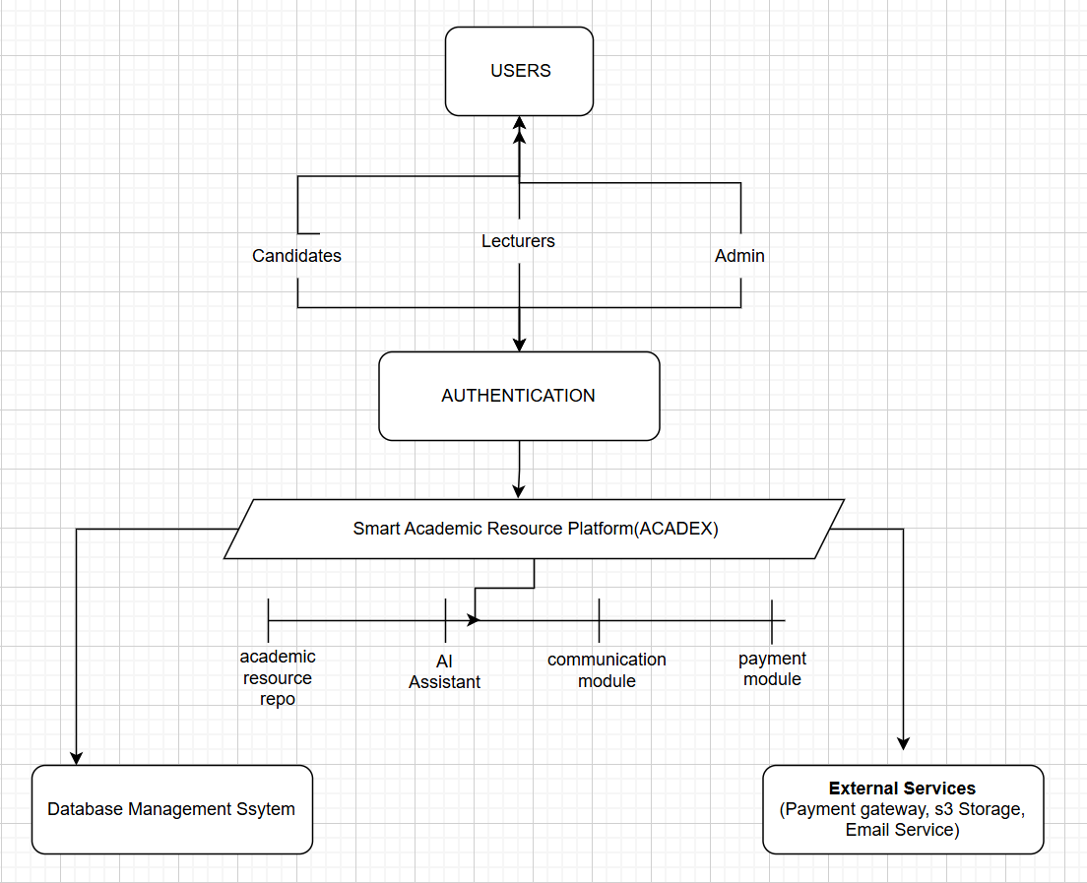
Figure 1.1: Functional Diagram of the Proposed System
The operation of the system begins when users register and authenticate themselves. The authentication module verifies user credentials and grants access according to assigned roles.
3.2.3 System Usecase Diagram
The interaction between the different categories of users and the system is illustrated by the use case diagram shown in Figure 3.2.
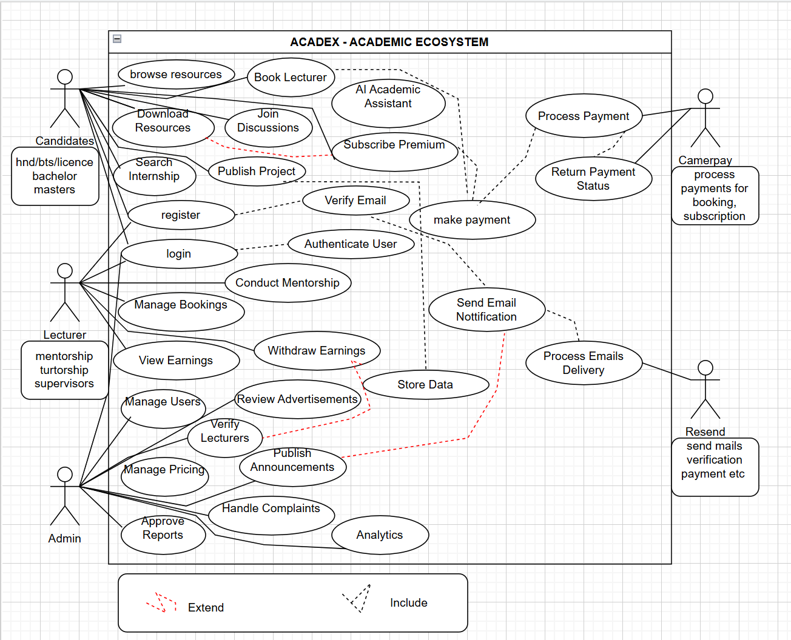
Figure 2 System Usecase Diagram
3.2.4 Flowchat Diagram
The operational sequence followed by the system is represented using a flowchart shown in Figure 3.3.
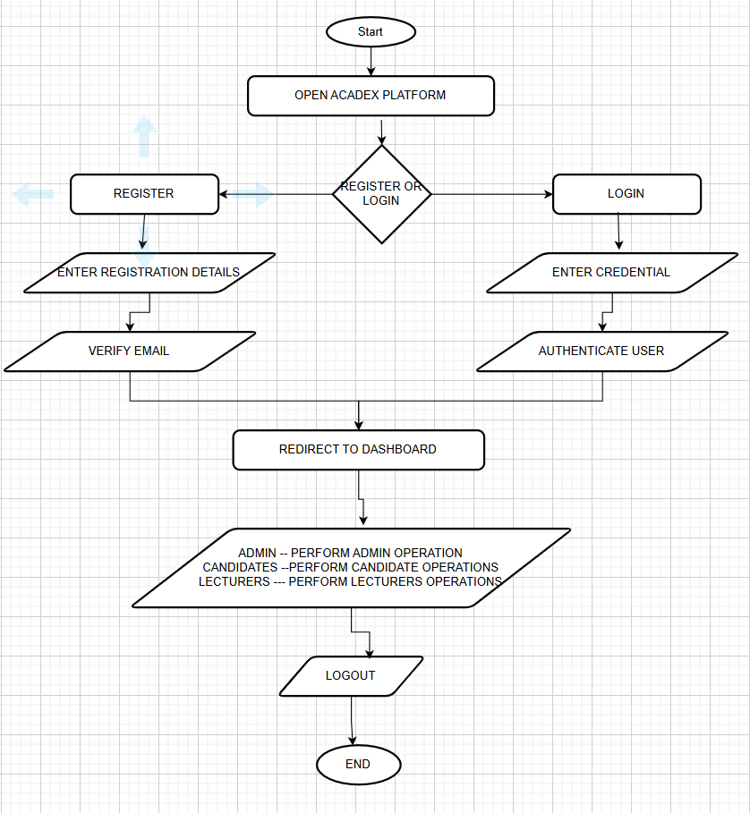
Figure 3 Flowchat Diagram
3.2.2 Class Diagram/Database Design
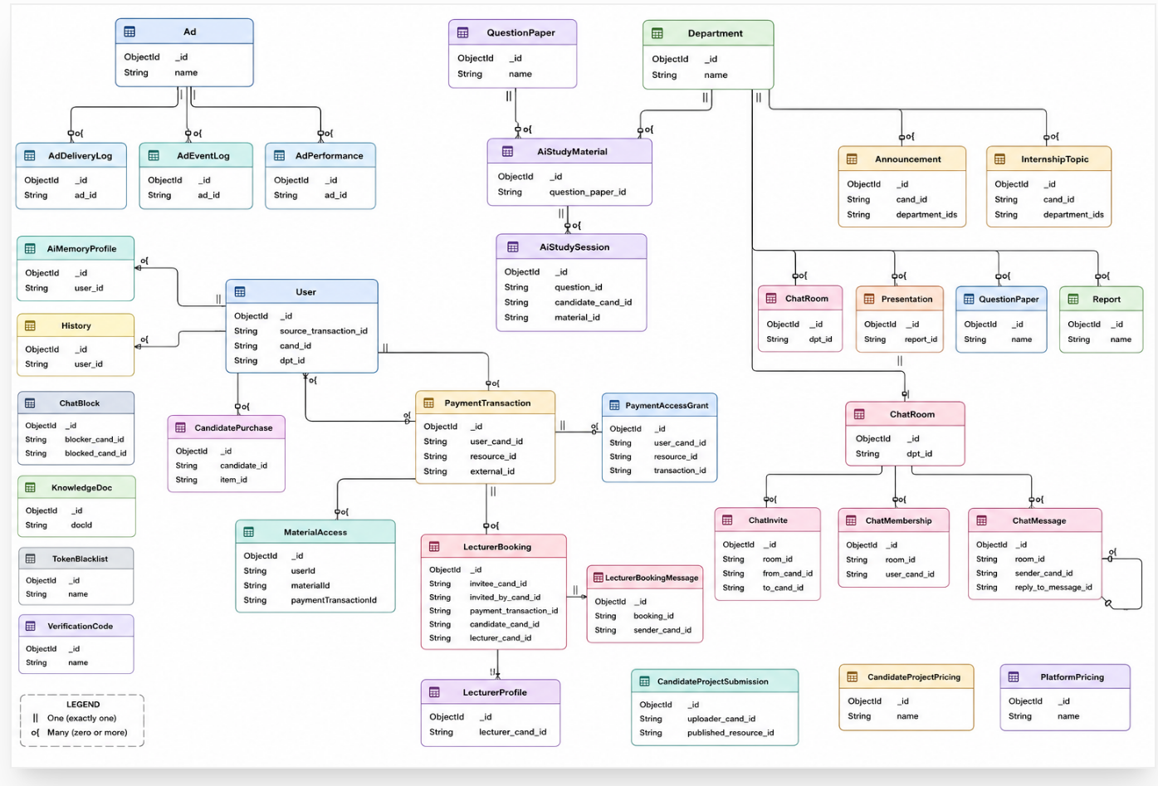
Figure 4 Class diagram
After successful authentication, users can interact with the appropriate system modules.
Candidates can access academic resources such as examination papers, internship topics, reports, and presentations. They can also interact with AI academic assistance, communicate with lecturers, participate in academic groups, book mentorship sessions, and receive institutional announcements.
Lecturers can provide academic support by uploading verified resources, offering mentorship services, managing consultation schedules, interacting with students, and receiving payments for approved mentorship activities.
Administrators manage the overall operation of the platform by verifying users, approving uploaded academic materials, managing announcements, monitoring transactions, and ensuring that system activities comply with platform requirements.
The academic resource repository serves as the central component of the system by storing and organizing learning materials, project reports, examination resources, and other academic information. The communication and mentorship modules improve interaction between students and lecturers, while AI services provide intelligent academic support.
The functional design ensures that all system components work together as a unified academic ecosystem rather than operating as independent services. This approach addresses the limitations identified in existing academic platforms by combining resource management, collaboration, mentorship, and intelligent assistance within one centralized platform.

3.2.3 Hardware and Software Requirements
The successful development and implementation of the proposed Smart Academic Resource Management Platform (ACADEX) required appropriate hardware and software resources. These resources provided the necessary environment for designing, developing, testing, and deploying the system.
3.2.3.1 Hardware Requirements
Table 3 Hardware Requirements
Hardware | Purpose
Laptop/Personal Computer | Used for software design, programming, testing, debugging, and documentation of the system.
Smartphone | Used to test the responsiveness and functionality of the platform on mobile devices.
Internet Connection | Enabled access to online documentation, package repositories, cloud services, APIs, version control, and deployment platforms.
External Storage Device (Optional) | Used for backing up project files, source code, and documentation during development.
The laptop served as the primary development workstation, while smartphones were used to verify that the application functioned correctly across different screen sizes. A reliable internet connection was necessary for downloading development packages, integrating external services, and publishing updates.
3.2.3.2 Software Requirements
The software tools selected for this project were chosen based on their performance, scalability, security, and compatibility with modern web application development. According to Pressman and Maxim, selecting appropriate development tools contributes significantly to software quality and maintainability [22].
Table 4 Software Requirements
Software | Purpose
Visual Studio Code | Integrated Development Environment (IDE) used for writing, editing, and debugging source code.
React.js | Used to develop the interactive frontend user interface of the platform.
Node.js | Runtime environment used to execute server-side JavaScript code.
Express.js | Backend framework used to develop RESTful APIs and manage server-side operations.
MongoDB | NoSQL database used to store users, academic resources, messages, payments, and other application data.
Mongoose | Object Data Modeling (ODM) library used to define schemas and manage interactions with MongoDB.
Git and GitHub | Used for version control, source code management, and project backup.
Postman | Used for testing and validating API endpoints during backend development.
Web Browser (Google Chrome/Microsoft Edge) | Used to test and verify the functionality of the web application.
The selected software tools provided a complete development environment for implementing both the frontend and backend components of the platform. Their integration enabled efficient coding, testing, debugging, and deployment while ensuring that the application remained scalable and maintainable.

3.3 IMPLEMENTATION
Implementation is the stage where the planned system design is transformed into a functional software application. During this phase, the identified requirements, functional design, and selected technologies were integrated to develop the proposed Smart Academic Resource Management Platform (ACADEX). The implementation process involved developing the user interface, backend services, database, and integrating external services to provide a secure and efficient academic ecosystem.
The implementation was carried out using an iterative development approach, allowing individual modules to be developed, tested, and refined before being integrated into the complete system. This approach improved software quality by enabling continuous evaluation and correction of identified issues throughout the development process [22].
3.3.1 Frontend Implementation
The frontend was developed using React.js, which provides a component-based architecture for building responsive and interactive user interfaces. The platform was designed to provide a consistent user experience across desktop and mobile devices.
The frontend implementation included the development of:
User registration and authentication interfaces.
Candidate, Lecturer, and Administrator dashboards.
Academic resource pages for internship topics, reports, presentations, and question papers.
AI interaction interface.
Mentorship booking pages.
Communication and discussion interfaces.
Payment and subscription pages.
Notification and profile management pages.
Client-side validation was implemented to ensure that user inputs were complete and correctly formatted before being submitted to the server.
3.3.2 Backend Implementation
The backend was implemented using Node.js[20] and Express.js to manage business logic and communication between the frontend and the database.
The backend performs several important functions, including:
User authentication and authorization.
Management of academic resources.
Lecturer verification.
Mentorship booking management.
Processing of subscriptions and payments.
Notification management.
AI request processing.
File upload and retrieval.
RESTful API services.
Security measures such as password hashing, JSON Web Token (JWT[23]) authentication, input validation, and role-based access control were implemented to protect user information and restrict unauthorized access.
3.3.3 Database Implementation
The platform uses MongoDB, a NoSQL document-oriented database, to store and manage application data. MongoDB[22] was selected because of its flexibility, scalability, and ability to efficiently handle large volumes of structured and semi-structured data.
The database stores information related to:
User accounts.
Academic departments.
Internship topics.
Past examination papers.
Research reports.
Presentation files.
Mentorship bookings.
Messages and discussions.
Notifications.
Payments and subscriptions.
User activities.
Appropriate validation rules and indexing techniques were implemented to improve data integrity, retrieval efficiency, and overall system performance.
3.3.4 Integration of System Modules
The implementation process involved integrating the major functional modules to ensure that they operate as a unified system.
The principal modules implemented include:
Authentication Module, responsible for user registration, login, and access control.
Academic Resource Module, responsible for managing internship topics, reports, presentations, and examination papers.
Artificial Intelligence Module, which provides intelligent academic assistance and learning support.
Mentorship Module, enabling students to schedule consultations with verified lecturers.
Communication Module, supporting announcements, messaging, and academic discussion groups.
Payment Module, responsible for processing subscriptions and mentorship payments through Mobile Money services.
Administration Module, which manages users, academic resources, platform activities, and system monitoring.
The integration of these modules enables seamless interaction between users while ensuring efficient management of academic resources and services within a centralized platform.
3.3.5 System Testing
Testing was carried out throughout the implementation process to verify that each module performed according to the specified requirements. Both individual modules and the integrated system were evaluated to identify and correct functional errors before deployment.
The testing activities included:
Unit Testing, to verify the correctness of individual components.
Integration Testing, to ensure proper communication between system modules.
Functional Testing, to confirm that each feature operated according to its intended purpose.
User Acceptance Testing (UAT), conducted to validate that the system met user expectations and project objectives.
The successful completion of these tests confirmed that the developed platform functioned correctly and satisfied the identified functional requirements.

3.4 ANALYSIS
System analysis involves examining the requirements, feasibility, and expected performance of the proposed system before and during development. This process ensured that the developed platform effectively addressed the academic challenges identified in Chapter One while satisfying the needs of its intended users. The analysis also provided a basis for evaluating whether the proposed solution was technically, economically, and operationally feasible [22].
3.4.1 Requirement Analysis
The requirements of the proposed system were identified from the data collected through personal observation, discussions with students and lecturers, and the review of existing academic platforms and related literature. These requirements served as the foundation for the design and implementation of the platform.
The analysis revealed that users required a centralized system capable of:
- Providing access to internship and research topics.
- Preserving and sharing academic reports and presentations.
- Providing past examination papers for revision.
- Facilitating communication between students and lecturers.
- Supporting academic mentorship and consultation.
- Delivering AI-assisted academic support.
- Managing announcements, notifications, and user activities.
These requirements were categorized into functional and non-functional requirements.
3.4.2 Functional Requirements
Functional requirements describe the services and operations that the system must perform to satisfy user needs.
The proposed platform provides different functionalities based on user roles.
Candidate Functions
Candidates are able to:
- Register and authenticate their accounts.
- Manage personal profiles.
- Access internship topics and academic resources.
- Upload, download, and view academic reports and presentations.
- Access past examination papers.
- Interact with the AI academic assistant.
- Book mentorship sessions with lecturers.
- Participate in discussion groups and private messaging.
- Receive academic announcements and notifications.
- Submit feedback and reviews.
Lecturer Functions
Lecturers are able to:
- Register and complete account verification.
- Upload academic materials.
- Offer mentorship and consultation services.
- Manage consultation schedules.
- Communicate with students.
- Receive mentorship bookings.
- Request withdrawal of earnings.
Administrator Functions
Administrators are responsible for:
- Managing users and user roles, Verifying lecturers.
- Approving uploaded academic resources.
- Managing internship topics and examination papers.
- Publishing announcementsResolving complaints.
- Monitoring platform activities.
3.4.3 Non-Functional Requirements
Non-functional requirements define the quality attributes expected from the system.
The proposed platform was designed to satisfy the following quality requirements:
- Performance: The system should process user requests efficiently and provide fast response times.
- Security: User data should be protected through password encryption, authentication, authorization, and input validation.
- Reliability: The platform should provide consistent and dependable services with minimal downtime.
- Scalability: The system should accommodate increasing numbers of users and academic resources without significant performance degradation.
- Usability: The user interface should be simple, intuitive, and accessible to users with different levels of technical experience.
- Maintainability: The modular architecture should simplify future updates, debugging, and feature enhancements.
3.4.4 Feasibility Analysis
A feasibility analysis was conducted to determine whether the proposed system could be successfully developed and deployed within the available resources.
Technical Feasibility
The project was technically feasible because the selected technologies, including React.js, Node.js, Express.js, MongoDB, and supporting development tools, provide the functionality required to develop a secure, scalable, and responsive web application. These technologies are widely adopted in modern software development and are supported by extensive documentation and developer communities [22].
Economic Feasibility
The project was economically feasible because it primarily utilized open-source software and freely available development tools. This significantly reduced software licensing costs while providing a robust development environment. Operational expenses were also minimized through the use of cloud-based services and scalable deployment options.
Operational Feasibility
The proposed platform was designed with ease of use in mind, making it suitable for students, lecturers, researchers, and administrators. The centralized design simplifies access to academic resources and services, thereby improving user productivity and reducing dependence on multiple independent systems.
Schedule Feasibility
The project was completed within the planned development schedule. The adoption of an iterative development approach enabled continuous testing, evaluation, and refinement of individual modules throughout the implementation process, ensuring timely completion of the system.

3.6 CHAPTER SUMMARY
This chapter presented the research methodology adopted for the development of the proposed Smart Academic Resource Management Platform (ACADEX). It described the area of study, planning activities, data collection methods, functional design, hardware and software requirements, implementation process, and system analysis. The chapter also discussed the functional and non-functional requirements, feasibility analysis, and maintenance support strategies adopted to ensure the successful development and sustainability of the platform.

CHAPTER FOUR

PRESENTATION AND DISCUSSION OF FINDINGS

4.1 PRESENTATION OF FINDINGS
This section presents the results obtained from the data collection process. The findings are presented using tables, charts, and descriptive analysis to illustrate the academic challenges experienced by students and lecturers, as well as the justification for the proposed Smart Academic Resource Management Platform.
4.1.1 Questionnaire Response Rate
A total of 100 questionnaires were distributed to respondents comprising 50 students and 50 lecturers. Out of these, 92 completed questionnaires were returned, representing an overall response rate of 92%, which was considered adequate for the study.

Figure 5 Questionnaire Response Rate Chart
Discussion
The high response rate indicates that both students and lecturers were interested in contributing to the study. Students recorded a slightly higher participation rate than lecturers, reflecting their greater interest in improvements to academic resource management.
4.1.2 Summary of Key Findings from the Survey

Figure 6 Summary of Key Findings from the Survey
This chart clearly shows that students expressed stronger support across all proposed services, with positive responses averaging approximately 15% higher than those of lecturers. Though both students and lecturers have good interest for the project

4.2 DISCUSSION OF FINDINGS
The findings demonstrate strong support for the development of an integrated academic resource management platform. Students consistently expressed greater enthusiasm for the proposed services than lecturers, reflecting the greater academic challenges they encounter in accessing learning materials, internship opportunities, and previous research works. Although lecturers also supported the proposed platform, many emphasized the importance of content verification, secure authentication, and quality assurance to maintain academic integrity. These recommendations influenced the implementation of administrator approval mechanisms, lecturer verification, and moderation of uploaded resources.
Furthermore, the strong demand for centralized repositories, AI-assisted learning, mentorship services, and academic communication aligns with the problems identified in Chapter One and supports the study's primary objective of developing a Smart Academic Resource Management Platform. The findings also corroborate the literature reviewed in Chapter Two, which highlighted the growing importance of digital repositories, intelligent learning systems, and collaborative academic platforms in improving access to educational resources and preserving academic knowledge.

CHAPTER FIVE

SUMMARY OF FINDINGS, CONCLUSION AND RECOMMENDATIONS

5.1 SUMMARY OF FINDINGS
This study focused on the design and development of a Smart Academic Resource Management Platform (ACADEX) aimed at addressing challenges related to academic resource accessibility, knowledge preservation, mentorship, communication, and collaboration among students, lecturers, and academic institutions.
The study was motivated by challenges encountered during the academic journey of the researcher, particularly difficulties in obtaining suitable internship topics, accessing previously defended project reports, finding past examination papers, receiving academic guidance, and preserving valuable student research works. The review of existing academic platforms revealed that most available solutions focus on specific academic services, such as online learning or examination preparation, without providing an integrated ecosystem that combines academic resources, mentorship, artificial intelligence, communication, and collaboration.
Data was collected through questionnaires distributed to students and lecturers, as well as through the analysis of existing academic systems and relevant literature. A total of 100 questionnaires were distributed, consisting of 50 students and 50 lecturers. The findings showed strong support for the development of a centralized academic platform, with students demonstrating a higher level of acceptance compared to lecturers. Respondents identified access to past examination papers, internship topics, defended reports, academic announcements, AI-assisted learning, and mentorship services as important requirements for improving academic activities.
The analysis of existing systems further revealed that although platforms such as examination resource platforms and digital learning systems provide valuable services, they have limitations in areas such as academic project preservation, lecturer mentorship, AI-based academic assistance, and integrated communication. These findings established the need for a more comprehensive academic ecosystem.
Based on the identified challenges and requirements, ACADEX was successfully developed as an integrated academic platform providing centralized access to internship topics, examination papers, defended reports, presentations, academic publications, AI-assisted learning support, lecturer mentorship, communication tools, announcements, and digital payment services.
The system was developed using the Agile Software Development Methodology, allowing continuous improvement through iterative development and testing. Modern technologies including React.js[19], Node.js, Express.js, MongoDB, JSON Web Token (JWT), Artificial Intelligence services, and Mobile Money APIs were utilized to achieve a secure, scalable, and maintainable platform.
The successful implementation of ACADEX demonstrates that the objectives of the study were achieved by providing a unified platform that improves access to academic resources, promotes knowledge sharing, supports collaboration between students and lecturers, and preserves academic works for future generations.

5.2 RECOMMENDATIONS
Based on the findings of this study, the following recommendations are proposed:
Educational institutions should adopt centralized academic resource management systems to improve access to learning materials, research works, and academic support services.
Universities and higher institutions should encourage students to publish and preserve defended projects through verified digital repositories to prevent the loss of valuable academic knowledge.
Lecturers should actively participate in digital mentorship platforms by providing guidance, consultation services, and academic resources to support students throughout their academic journey.
Institutions should promote the responsible use of Artificial Intelligence in education to improve research assistance, personalized learning, and academic productivity while maintaining academic integrity.
Academic stakeholders should collaborate in developing interconnected digital ecosystems that support students, lecturers, researchers, and institutions through accessible educational technologies.
Future versions of ACADEX should integrate additional payment services and institutional systems to increase accessibility and support wider adoption.

5.3 CONCLUSION
This study successfully designed and implemented ACADEX, a Smart Academic Resource Management Platform developed to address challenges associated with academic resource accessibility, research preservation, mentorship, communication, and collaboration.
The research findings demonstrated that students and lecturers experience difficulties accessing essential academic resources due to the absence of a centralized platform that combines multiple academic services. Existing systems reviewed during the study were found to provide useful services but lacked comprehensive integration of features such as academic repositories, AI assistance, mentorship, collaboration, and knowledge preservation.
ACADEX addresses these limitations by providing an integrated digital ecosystem where students can access academic resources, publish and preserve research works, interact with lecturers, receive AI-assisted support, and participate in academic collaboration. Lecturers can provide mentorship, share resources, and interact with students, while administrators can manage resources, users, and platform activities.
The successful implementation of the platform confirms that the objectives of the study were achieved. The system provides a foundation for improving digital academic support and demonstrates the potential of integrated academic platforms in enhancing accessibility, collaboration, and knowledge management within educational environments.

5.4 LIMITATIONS OF THE STUDY
Although the study achieved its objectives, some limitations were identified during the research and development process.
The developed platform is currently available as a web application and requires internet connectivity for users to access its services. This may limit accessibility for users in areas with unstable internet connections.
The system relies on external Artificial Intelligence services, which may introduce limitations related to availability, cost, and dependency on third-party providers. Additionally, the current payment integration supports selected Mobile Money services and does not yet include all possible payment methods.
The platform has limited integration with existing institutional management systems and national examination bodies. Furthermore, due to the scope and duration of the project, advanced features such as large-scale analytics, extensive video conferencing capabilities, and automated academic verification mechanisms were not fully implemented.
These limitations provide opportunities for future improvements and expansion of the system.

5.5 SUGGESTIONS FOR FURTHER RESEARCH
Future research and development efforts can focus on improving and expanding ACADEX through the following areas:
Development of dedicated Android and iOS mobile applications to improve accessibility and user experience.
Integration with university management systems and national examination platforms to enable automated academic information exchange.
Enhancement of Artificial Intelligence features through:
intelligent internship topic recommendation,
plagiarism detection,
personalized learning recommendations,
automated academic feedback.
Development of improved video conferencing and virtual classroom capabilities to enhance lecturer-student interaction.
Implementation of offline access functionality allowing users to access previously downloaded academic resources without continuous internet connectivity.
Integration of advanced verification technologies such as blockchain-based academic project authentication to improve trust and prevent unauthorized modification of published academic works.
Expansion of the platform to support more institutions, countries, and academic programmes while integrating additional payment providers and institutional services.

REFERENCES IEEE-STYLE
[1] UNESCO, Artificial Intelligence and Education: Guidance for Policy-makers. Paris, France: UNESCO, 2021.
[2] S. Zawacki-Richter, V. I. Marín, M. Bond, and F. Gouverneur, “Systematic review of research on artificial intelligence applications in higher education – where are the educators?,” International Journal of Educational Technology in Higher Education, vol. 16, no. 39, pp. 1–27, 2019.
[3] J. W. Creswell and J. D. Creswell, Research Design: Qualitative, Quantitative, and Mixed Methods Approaches, 6th ed. Thousand Oaks, CA, USA: SAGE Publications, 2023.
[4] UNESCO, Global Education Monitoring Report 2023: Technology in Education—A Tool on Whose Terms? Paris, France: UNESCO Publishing, 2023.
[5] C. A. Lynch, “Institutional repositories: Essential infrastructure for scholarship in the digital age,” portal: Libraries and the Academy, vol. 3, no. 2, pp. 327–336, 2003.
[6] K. C. Laudon and J. P. Laudon, Management Information Systems: Managing the Digital Firm, 17th ed. London, UK: Pearson, 2022.
[7] W. Holmes, M. Bialik, and C. Fadel, Artificial Intelligence in Education: Promises and Implications for Teaching and Learning. Boston, MA, USA: Center for Curriculum Redesign, 2019.
[8] M. Bond, S. Bedenlier, V. I. Marín, and M. Händel, “Emergency remote teaching in higher education: Mapping the first global online semester,” International Journal of Educational Technology in Higher Education, vol. 17, no. 1, pp. 1–24, 2020.
[9] J. J. Kidwell, K. M. Vander Linde, and S. L. Johnson, “Applying corporate knowledge management practices in higher education,” EDUCAUSE Quarterly, vol. 23, no. 4, pp. 28–33, 2000.
[10] Z. T. Zhu, M. H. Yu, and P. Riezebos, “A research framework of smart education,” Smart Learning Environments, vol. 3, no. 1, pp. 1–17, 2016.
[11] Moodle Pty Ltd., “Moodle Learning Management System Documentation,” 2024. [Online]. Available: https://docs.moodle.org
[12] The DSpace Project, “DSpace Digital Repository Documentation,” 2024. [Online]. Available: https://dspace.lyrasis.org
[13] Google LLC, “Google Classroom Help Center,” 2024. [Online]. Available: https://support.google.com/edu/classroom
[14] Cameroon General Certificate of Education Board, “Higher National Diploma Examination Information,” 2024. [Online]. Available: https://www.camgceb.org
[15] UNEE, “UNEE Learning Platform,” 2024. [Online]. Available: https://unee.app
[16] HND eLearning Hub, “Departmental eLearning Platform,” 2024.
[17] K. Beck et al., “Manifesto for Agile Software Development,” Agile Alliance, 2001. [Online]. Available: https://agilemanifesto.org
[18] I. Sommerville, Software Engineering, 10th ed. Boston, MA, USA: Pearson, 2015.
[19] Meta Platforms Inc., “React Documentation,” 2024. [Online]. Available: https://react.dev
[20] OpenJS Foundation, “Node.js Documentation,” 2024. [Online]. Available: https://nodejs.org
[21] OpenJS Foundation, “Express.js Documentation,” 2024. [Online]. Available: https://expressjs.com
[22] MongoDB Inc., “MongoDB Documentation,” 2024. [Online]. Available: https://www.mongodb.com/docs
[23] Auth0, “JSON Web Token Introduction,” 2024. [Online]. Available: https://jwt.io
[24] Socket.IO, “Socket.IO Documentation,” 2024. [Online]. Available: https://socket.io/docs
[25] R. S. Pressman and B. R. Maxim, Software Engineering: A Practitioner’s Approach, 9th ed. New York, NY, USA: McGraw-Hill Education, 2020.

APPENDIX A: SYSTEM SCREENSHOTS
Representative screenshots include:
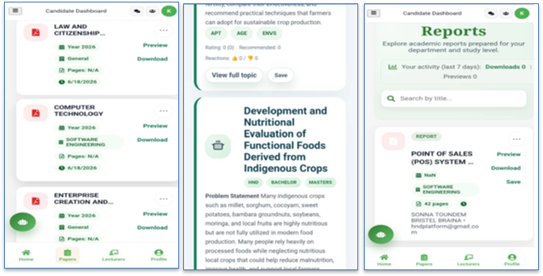
Figure 7 Question papers, Internship Topics, Report Repository Screenshot
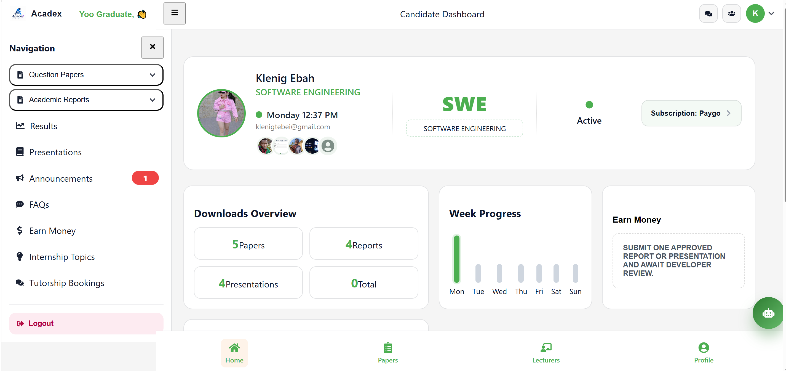
Figure 8 Candidate Dashboard Screenshot
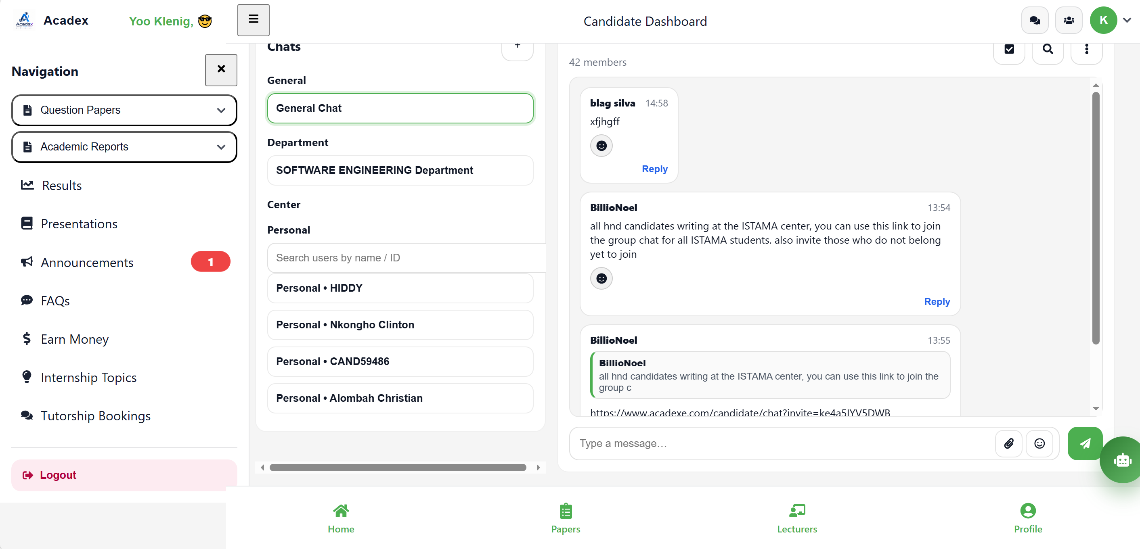
Figure 9 Chat section candidate site
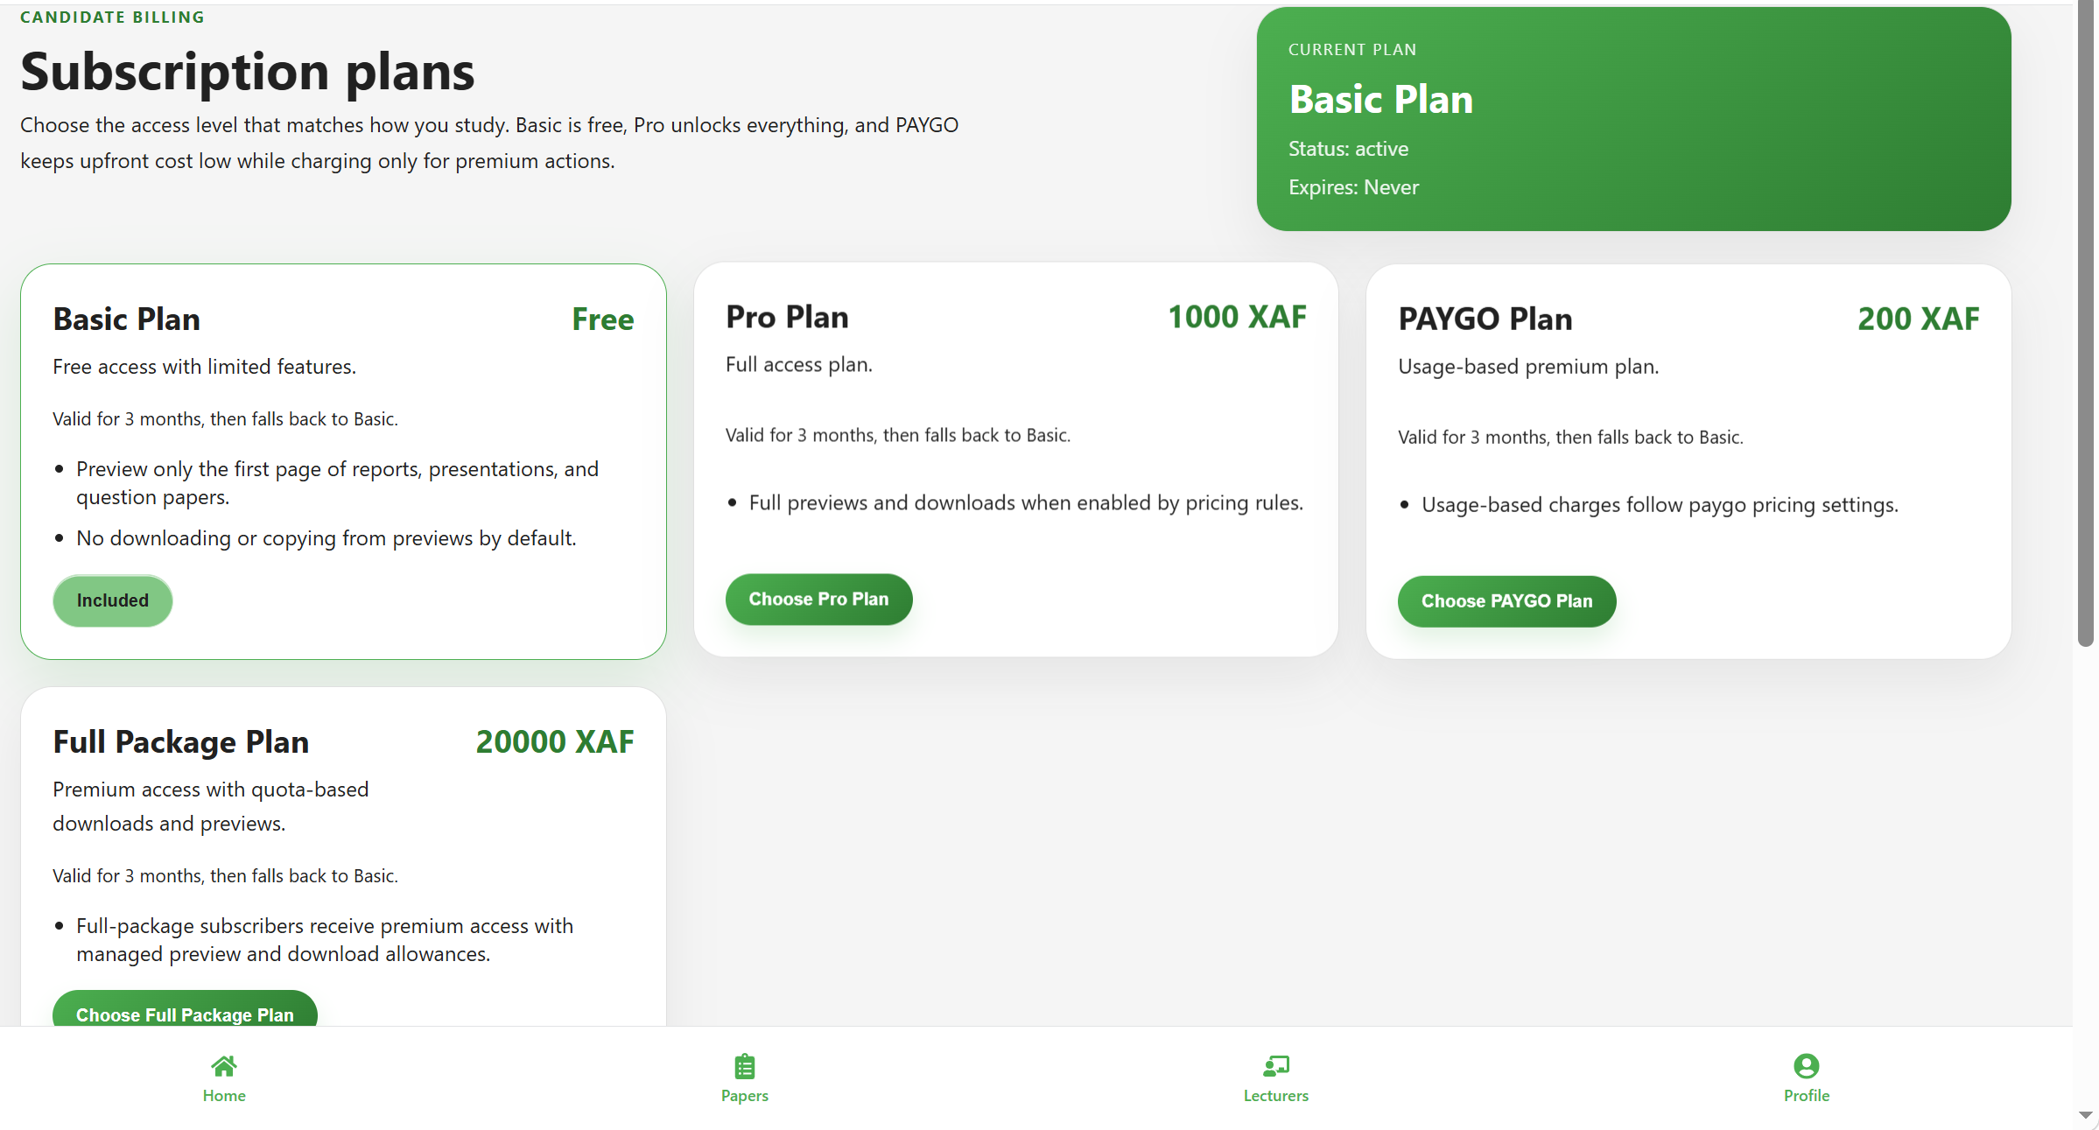
Figure 10 Subscription component

APPENDIX B: QUESTIONNAIRE
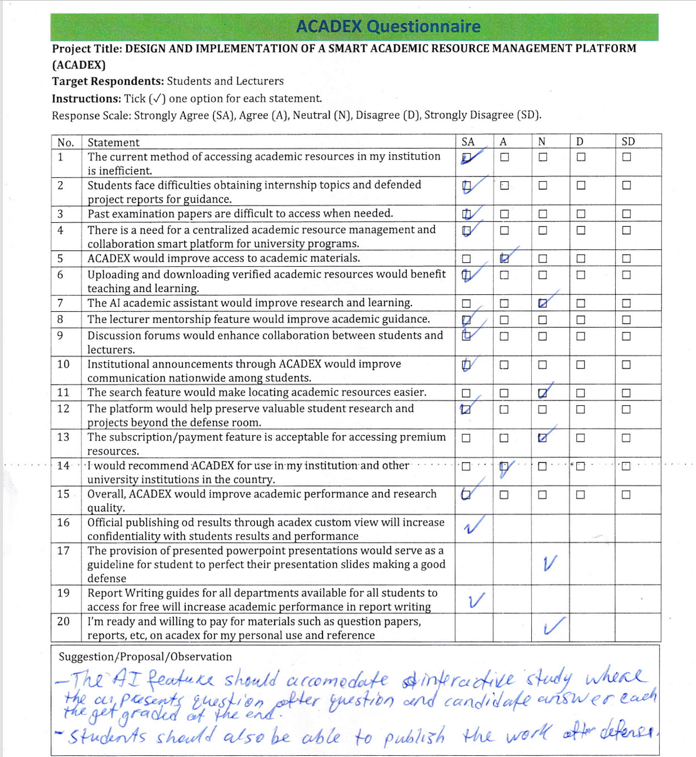
Figure 11 Questionaire

APPENDIX C: SAMPLE SYSTEM OUTPUTS
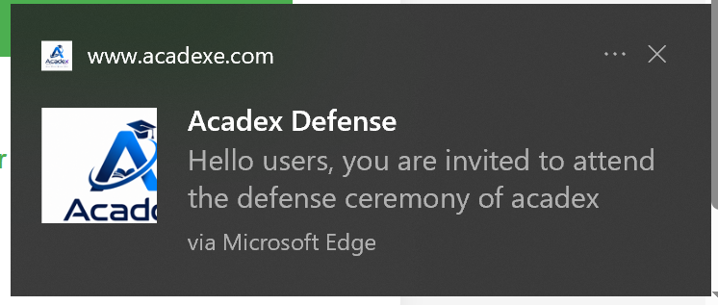
Figure 12 Push Notification
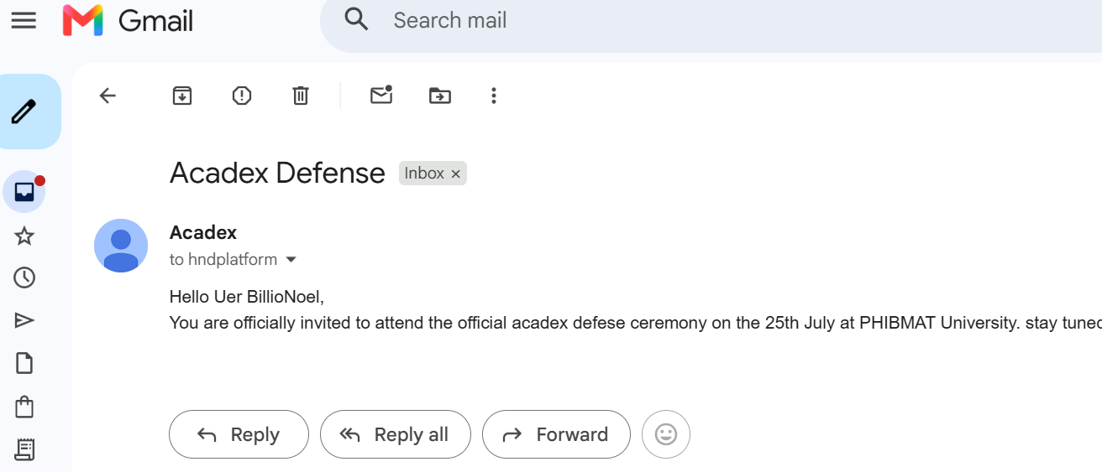
Figure 13 Email notification

